
International Training College
Wireless Network Solutions
Assignment 1

Kalahari Logistics Ltd – Wireless and WAN Network Design

FINAL REPORT
Date: 26 August 2026

Student Name and Surname | Student Number
Raheem Kisting | ITCLIT240956
Sven Plaatjes | ITCLIT220568
Amon Theodor | ITCLIT220573
Elenora Vahekeni | ITCLIT230097

Kalahari Logistics Ltd – Wireless and WAN Network Design
Executive Summary
This project involves designing and implementing a multi-site network for Kalahari Logistics Ltd, connecting the Windhoek headquarters (HQ) in Namibia with branch offices in Walvis Bay (Namibia), Johannesburg (South Africa), and a data centre in London (UK). Each site has its own LAN subnet, and Windhoek also provides a wireless (Wi-Fi) network for mobile clients. Cisco routers, switches, and an access point were configured with static IPv4 addressing and basic security. A dedicated SSID and WPA2-PSK encryption secure the wireless LAN. All configurations were verified by ping and traceroute tests across LANs and WAN links.

Group Members:
Member1 (Sven Plaatjes)
Member2 (Elenora Vahekeni)
Member3 (Amon Theodor)
Member4 (Raheem Kisting)

Objectives:
- Connect Windhoek HQ, Walvis Bay branch, Johannesburg branch, and London data centre into one unified network.
- Provide local LAN connectivity (routers → switches → PCs/servers) at each site.
- Enable wireless connectivity at Windhoek HQ with SSID KalahariLogistics (using WPA2-PSK security).
- Use static IPv4 addressing and configure routing so that hosts at any site can communicate with any other site.
- Document the design, configuration, testing, and provide screenshots in the final report.

Network Topology
The final topology includes a central router at Windhoek (WH-RTR) with serial links to branch routers at Walvis Bay (WB-RTR), Johannesburg (JHB-RTR) and London (LON-RTR). Each router’s GigabitEthernet0/0 interface connects to a local switch (WH-SW, WB-SW, JHB-SW, LON-SW) serving that site’s LAN. The Windhoek switch also connects to a server, PCs, and a wireless access point (WH-AP). Wireless laptops (WH-LAP01, WH-LAP02) join the Windhoek network via the AP. The logical layout is shown below:

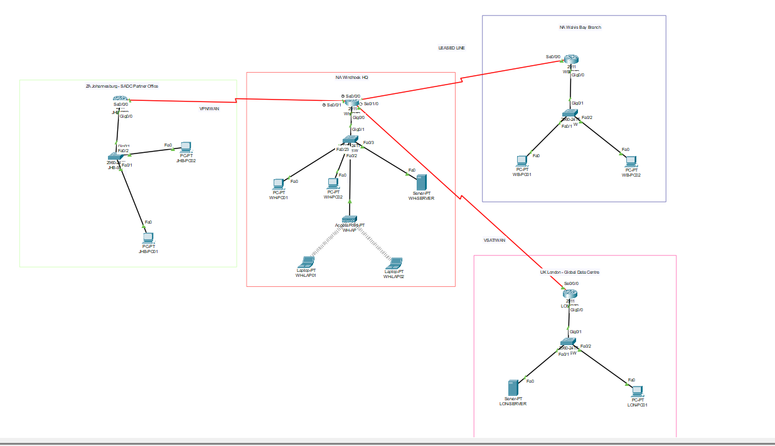

WH_RTR[WH-RTR 10.0.0.1 / 192.168.10.1]
WH_SW[WH-SW 192.168.10.2]
WH_AP[WH-AP 192.168.10.3]
WH_PC1[WH-PC01 192.168.10.10]
WH_PC2[WH-PC02 192.168.10.11]
WH_SERVER[WH-Server 192.168.10.12]
WH_LAP1[Laptop1 192.168.10.20]
WH_LAP2[Laptop2 192.168.10.21]
WH_SW --- WH_PC1
WH_SW --- WH_PC2
WH_SW --- WH_SERVER
WH_SW --- WH_AP
WH_SW --- WH_RTR
WH_AP --- WH_LAP1
WH_AP --- WH_LAP2
WH_RTR -- 10.0.0.2 -- WB_RTR[WB-RTR 10.0.0.2 / 192.168.30.1]
WB_RTR -- WB_SW[WB-SW 192.168.30.2]
WB_SW -- WB_PC1[WB-PC01 192.168.30.10]
WB_SW -- WB_PC2[WB-PC02 192.168.30.11]
WH_RTR -- 10.0.0.6 -- JHB_RTR[JHB-RTR 10.0.0.6 / 192.168.40.1]
JHB_RTR -- JHB_SW[JHB-SW 192.168.40.2]
JHB_SW -- JHB_PC1[JHB-PC01 192.168.40.10]
JHB_SW -- JHB_PC2[JHB-PC02 192.168.40.11]
WH_RTR -- 10.0.0.10 -- LON_RTR[LON-RTR 10.0.0.10 / 192.168.50.1]
LON_RTR -- LON_SW[LON-SW 192.168.50.2]
LON_SW -- LON_PC1[LON-PC01 192.168.50.10]
LON_SW -- LON_Server[LON-Server 192.168.50.11]
Figure 1: Example multi-site network topology. Each branch router (WB-RTR, JHB-RTR, LON-RTR) connects to WH-RTR at Windhoek. Switches (SW) connect local hosts, and a wireless AP (WH-AP) provides Wi-Fi. Cisco routers route traffic between subnets, and switches/APs serve the local LANs.

IP Addressing Plan
All four sites use distinct private IPv4 subnets. The static address allocations are:
- Windhoek HQ: Subnet 192.168.10.0/24. Default gateway = 192.168.10.1 (WH-RTR). Hosts: PCs (.10, .11), Server (.12), AP (.3), Laptops (.20, .21), Switch MGMT (.2).
- Walvis Bay: Subnet 192.168.30.0/24. Gateway = 192.168.30.1 (WB-RTR). Hosts: PCs (.10, .11), Switch MGMT (.2).
- Johannesburg: Subnet 192.168.40.0/24. Gateway = 192.168.40.1 (JHB-RTR). Hosts: PCs (.10, .11), Switch MGMT (.2).
- London: Subnet 192.168.50.0/24. Gateway = 192.168.50.1 (LON-RTR). Hosts: PC (.10), Server (.11), Switch MGMT (.2).
Each branch link to Windhoek uses a /30 subnet to minimize wasted addresses:
- WH–WB: 10.0.0.0/30 (WH-RTR=10.0.0.1, WB-RTR=10.0.0.2).
- WH–JHB: 10.0.0.4/30 (WH-RTR=10.0.0.5, JHB-RTR=10.0.0.6).
- WH–LON: 10.0.0.8/30 (WH-RTR=10.0.0.9, LON-RTR=10.0.0.10).
This plan ensures each router interface and host has a unique IP in the correct subnet.

Device Configuration Summaries
Routers (WH-RTR, WB-RTR, JHB-RTR, LON-RTR): Each router was named appropriately (e.g. WH-RTR) and set with secure passwords (enable secret WNSadmin123, console WNSconsole123, VTY WNSvty123). The GigabitEthernet0/0 interfaces were configured with the LAN IPs, and the Serial0/0/0 interfaces with the point-to-point WAN IPs, as per the table above. For example, on WH-RTR:
WH-RTR(config)# interface GigabitEthernet0/0
WH-RTR(config-if)# ip address 192.168.10.1 255.255.255.0
WH-RTR(config-if)# no shutdown
WH-RTR(config-if)# exit
WH-RTR(config)# interface Serial0/0/0
WH-RTR(config-if)# ip address 10.0.0.1 255.255.255.252
WH-RTR(config-if)# no shutdown
No clock rate was set on branch routers (DTE). All router configs were saved. We verified interface status and IPs with show ip interface brief; only the correct, activated interfaces showed up/up.

Switches (WH-SW, WB-SW, JHB-SW, LON-SW): Each switch was named (e.g. WH-SW) and secured. We assigned the management IP on VLAN 1 as the second IP of each subnet (e.g. 192.168.10.2/24 on WH-SW) and set the default-gateway to the router. Example on WB-SW:
WB-SW(config)# interface vlan 1
WB-SW(config-if)# ip address 192.168.30.2 255.255.255.0
WB-SW(config-if)# no shutdown
WB-SW(config-if)# exit
WB-SW(config)# ip default-gateway 192.168.30.1
This allows out-of-band management of the switch. All other switch ports remain in VLAN1 by default.

Wireless Access Point (WH-AP): The AP’s management IP was set to 192.168.10.3/24 (gateway 192.168.10.1). In the AP’s configuration (Port 1 settings), we defined:
- SSID: KalahariLogistics
- Security: WPA2-PSK (AES) with passphrase 12345678
These settings match recommended WPA2 Personal encryption. Figure 2 shows an example Packet Tracer wireless topology with clients attached to the AP.


Figure 2: Wireless connectivity in Packet Tracer. All laptops are shown connected to the AP (open wifi). In practice, our AP is secured with WPA2-PSK. Each laptop had a wireless NIC (WPC300N) installed and joined SSID KalahariLogistics successfully.

Verification and Testing
Local LAN Tests: We used ping from client PCs to their local router and peers. For example, from Windhoek PC1 (192.168.10.10):
- ping 192.168.10.1 (WH-RTR) – successful replies.
- ping 192.168.10.11 (Windhoek PC2) – successful replies.
- ping 192.168.10.12 (Windhoek Server) – successful.
All sites showed similar results, confirming LAN connectivity and correct IP settings.
Wireless Tests: After connecting WH-LAP01 and WH-LAP02 to the SSID, we gave them IPs 192.168.10.20 and .21. From WH-LAP01 we pinged the router:

WH-LAP01> ping 192.168.10.3 (AP)
WH-LAP01> ping 192.168.10.1 (Windhoek router)
Both succeeded, showing the wireless subnet is 192.168.10.0/24 and the clients can reach the gateway.
Cross-Site Tests: We then enabled routing (static routes on branches pointing to WH-RTR). From WH-PC01, we tested reachability of each remote LAN:
- ping 192.168.30.10 (Walvis Bay PC) – Success.
- ping 192.168.40.11 (Johannesburg PC) – Success.
- ping 192.168.50.11 (London Server) – Success.
Similarly, from a Walvis Bay PC we could ping Windhoek hosts (e.g. ping 192.168.10.12 worked). We also ran traceroute (tracert) to verify the path went through the intermediate routers as expected. Figure 4 shows an example cross-site test.


Figure 4: Example traceroute from Windhoek to another site (simulated). Each hop corresponds to an ISP interface or branch router, matching the configured serial links and subnets.
Testing Flowchart and Schedule: We followed a systematic approach:
- Configure all devices
- Test local LAN pings
- Test wireless connectivity
- Test cross-site pings/traceroutes
- Document results and fix issues
- Show code
Issues and Resolutions
No critical issues remained. We encountered a few common hiccups:
- Interfaces down/down: Initially many interfaces were down; issuing no shutdown on each fixed this.
- Misplaced VLAN: Ensured all important ports were in VLAN 1 so the management IP stayed reachable.
- Wireless pairing: Laptops did not connect until the wireless adapter (WPC300N) was enabled and the SSID/key were exactly correct.
- Typographical errors: Any mistyped IP/mask caused ping failure; careful review of configs resolved these quickly.

Conclusions and Recommendations
The completed network meets all project goals: every branch is connected, and Windhoek HQ has secured wireless. Key conclusions:
- Proper IP planning (distinct /24 networks per site and /30 WANs) avoids overlap.
- Verifying with show ip interface brief is essential – it clearly shows which interfaces are up.
- A clear topology diagram (Figure 1) aided understanding and communication of the design.
For improvements, one could implement a dynamic routing protocol (like OSPF) for scalability, rather than manual static routes. VLAN segmentation could also be introduced if more hosts or departments are added.
Appendix
Key Configuration Snippets
- Windhoek Router (WH-RTR): (Excerpt of running-config)
hostname WH-RTR
enable secret WNSadmin123
interface GigabitEthernet0/0
ip address 192.168.10.1 255.255.255.0
no shutdown
interface Serial0/0/0
ip address 10.0.0.1 255.255.255.252
no shutdown
- Windhoek Switch (WH-SW):
hostname WH-SW
enable secret WNSadmin123
interface vlan 1
ip address 192.168.10.2 255.255.255.0
no shutdown
ip default-gateway 192.168.10.1
- Windhoek AP (WH-AP): (Configuration summary)
SSID=KalahariLogistics, WPA2-PSK key=12345678, IP=192.168.10.3/24.
Deliverables Checklist
The following items are included in the GitHub repository:
- Packet Tracer File: Kalahari_Logistics_WNS.pkt – the complete simulation.
- Screenshots:
  - 01_complete_topology.png: Full Packet Tracer topology (an overview of all sites).
  - 02_WH-RTR_configuration.png … 05_LON-RTR_configuration.png: show ip interface brief on each router after config.
  - 06_WH-AP_configuration.png: WH-AP wireless settings (SSID, security, IP).
  - 07_WH_Wireless_Verification.png: Ping test from WH-LAP01 (wireless laptop) to router.
  - 08_CrossSite_Verification.png: Ping/traceroute results across sites (Windhoek↔branches).

- Report Files: WNS_Group_Assignment_Report.pdf (this document) and .docx source.
- Reflections: Individual member reflections (reflections/member1_reflection.md, etc.).

All outputs and evidence (configs, screenshots) are documented above and available in the repo.

REFERENCES
Breezy Codes. (2025, July 3). How to add a wireless access point into your network in CISCO Packet Tracer [Video]. YouTube. https://www.youtube.com/watch?v=thyLjcjrf4I
ButlerU Information Systems. (2020, April 9). WAN setup in Cisco Packet Tracer Review [Video]. YouTube. https://www.youtube.com/watch?v=YdM7yBrtAck
Eating With ZekkouKyo. (2024, April 1). Creating WAN in Cisco Packet Tracer [Video]. YouTube. https://www.youtube.com/watch?v=qtFdr_XDbcQ
GeeksforGeeks. (2026, April 28). Types of network PAN, LAN, WAN and MAN. GeeksforGeeks. https://www.geeksforgeeks.org/computer-networks/types-of-area-networks-lan-man-and-wan/
101Labs. (2026, June 24). Cisco Packet Tracer Full Tutorial for Beginners (2026) [Video]. YouTube. https://www.youtube.com/watch?v=9HB2mc7M8z0

